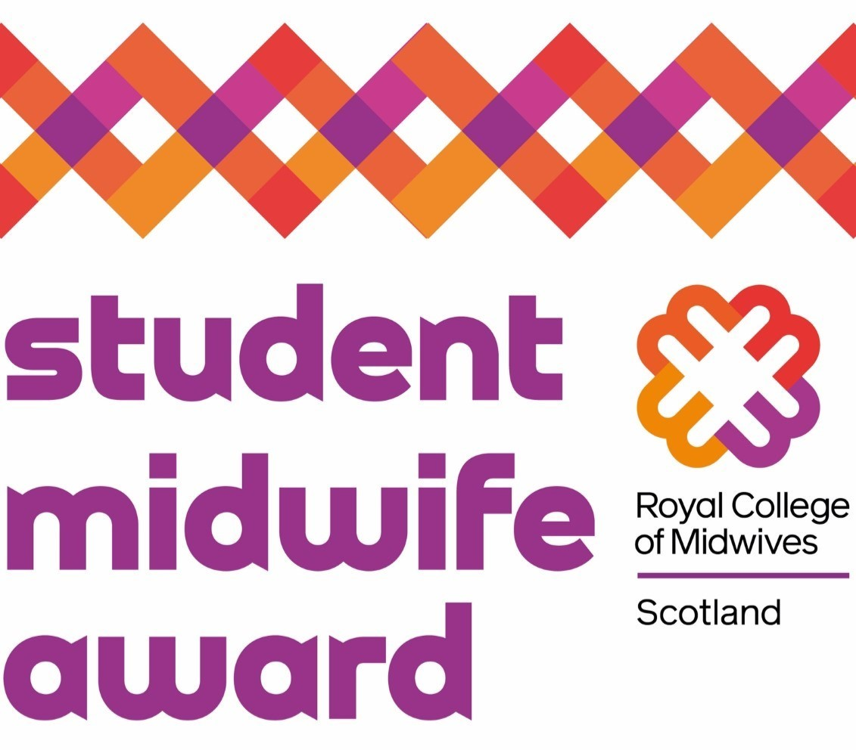

The RCM Student Midwife Awards celebrate the great work by students on both the MSc and BSc midwifery programmes in Scotland.

Showcase your project or dissertation by 20 September 2024, with finalists invited to the Strategic Midwifery Leadership (SMiLE) Conference on 28 November 2024.
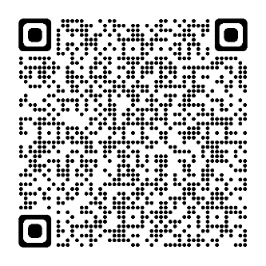
Register your interest by completing the
entry form using the QR code.

